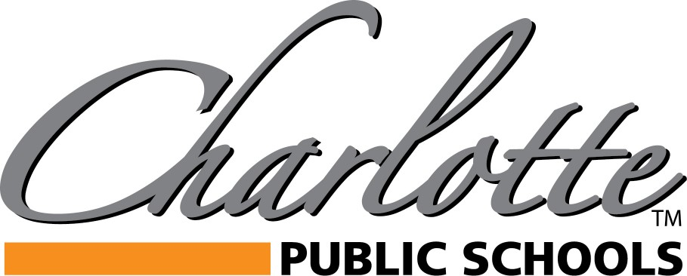

**2023 Board of Education Appointment Interest Form**

Please complete this form if you would like to express interest in a vacant Board of Education Trustee seat for the term now through- through December 31, 2024.

Full Legal Name: ________________________________________________________________

Primary Residence Address: _______________________________________________________

Primary Phone Number:___________________________ Are you a registered voter? □ Yes □ No

Do you reside within the boundaries of Charlotte Public Schools? □ Yes □ No

Why are you interested in filling a term on the Charlotte Board of Education?

|  |
| --- |
|  |

Is it your intention and are you able, if appointed, to fulfill the responsibilities of a Board member? □ Yes □ No

(Attend regular, special and subcommittee meetings and make decisions in the best interest of the entire school district according to federal, state, and local laws; established board policy; and the adopted strategic plan mission and vision. You may also be required to attend MASB training on the weekend & nights. There will also be special district events that require attendance such as groundbreaking ceremonies, student awards, graduation, etc.)

Applicant Signature:______________________________________ Date: _____________________

Please submit completed form to: April Delecki, Secretary to the Board, by email at delecka@charlottenet.org or mail to the address below:

Charlotte Public Schools Administrative Offices

Attention: Board of Education

378 State Street, Charlotte, MI 48813

**Deadline for Submission: Friday, August 25, 2023**

**Applicants will be able to speak to the Board of Education during Audience to Visitors on Monday, 8/28**

**CHS Media Center- 6 p.m.**

www.charlotteorioles.com