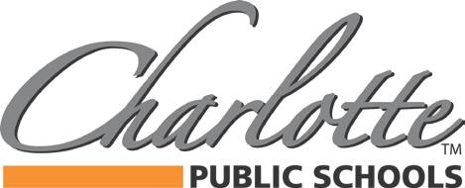

BUDGET AND SALARY/COMPENSATION TRANSPARENCY REPORT
DISTRICT PAID ASSOCIATION DUES/MEMBERSHIP
2019-2020

ASCD | 79.00
BCAM | 82.40
Capital Area Activities | 6,275.00
CAPT | 30.00
Charlotte Chamber of Commerce | 1,475.00
Charlotte Optimist Club | 180.00
CMSBO | 170.00
HPS | 3,275.00
Ingham ISD - REMC13 | 8,807.19
MASB | 6,023.68
MASSP | 1,300.00
MIAAA | 310.00
Michigan Association of School Administrators | 795.00
MASFSP | 85.00
MSBO | 760.00
MSBOA | 375.00
MSVMA | 790.00
MVCAM | 55.00
Rotary Club of Charlotte | 850.14
SNA | 107.00

378 State Street Charlotte, MI 48813 www.charlottenet.org

