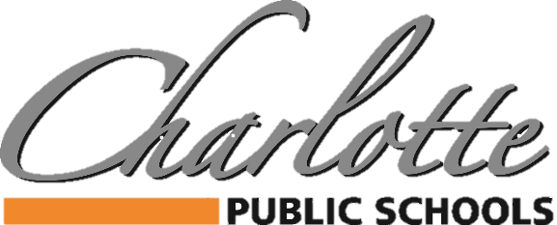

378 State Street, Charlotte, MI 48813 PH: 517.541.5100 FAX: 517.541.5105

March 13, 2020 @ 2:30 p.m.

Staff, Families, and Community Members:

The events of the last 48 hours are unprecedented, to say the least, with the rapid spread of COVID-19. This situation is impacting almost all aspects of our daily lives. We must be unified like never before as we work to stop the spread and help each other as individuals, neighbors and as a community.

Staff and student health are paramount for our districts. To that end, as school leaders we have been in constant communication with representatives from the local and state health departments, municipalities, State and community agencies, as well as leaders from higher education to gather data on this fluid situation. Information changed quickly yesterday, and with the announcement of further confirmed cases, including nearby counties, we fully support the Governor’s closure of districts.

During times of crisis, schools often assist and become a place of refuge in emergency operations. Our role during this event is quite the opposite, as we are asking the majority of staff and all students to stay home. In addition, the following closures or postponements are important to note:

- All IEP and other parent meetings will be postponed until after April 6, 2020.
- All community meetings, gatherings, rental use, assemblies, performances and any other events in our school facilities (indoor or outdoor) will be postponed until April 13, 2020.
- All activities associated with athletics or youth recreation (on or off campus) will be postponed until April 6, 2020.
- The Charlotte Performing Arts Center and the Charlotte Aquatic Center are closed until April 6, 2020.
- Visitors will not be allowed into any building without express permission by Central Administration until April 6, 2020.

We currently do not have guidance on whether the State will “forgive” instructional time, or if we will need to extend the end of the school year. If there is no forgiveness, we could potentially need to postpone the end of school until June 12, 2020, or longer, depending upon direction from the State of Michigan.

We do understand that many students rely on the District for food. We are proud to be able to offer daily ‘grab and go’ meal service, Monday-Friday for FREE. Please visit our website for more information.

Please continue to follow the recommendations to wash your hands, stay home when you are sick, and practice good hygiene. Also, please consider taking this time to thoroughly clean children’s outerwear, lunchboxes, blankets, etc.

We will continue to take necessary measures to keep our children, staff, and community safe. We will be sending out regular communications to keep staff and families informed. Please keep watch for more details in the coming weeks. Thank you for your patience during this challenging time.

Sincerely,
Dr. Mandy Stewart
Superintendent- Charlotte Public Schools

