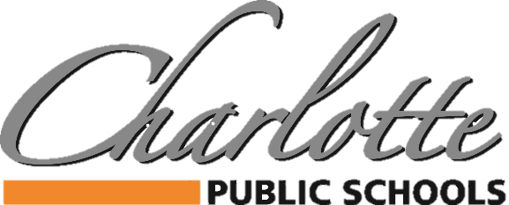

378 State Street, Charlotte, MI 48813 PH: 517.541.5100 FAX: 517.541.5105

Community Announcement
Additional Grab & Go Meal Locations Added

Due to the extraordinary efforts of many CPS staff members, we are pleased to be able to offer additional Grab & Go Meal locations for children and teens, 18 years old and younger.

Meals will be provided daily, Monday through Friday, beginning on the dates listed below.
Meals are FREE for children and teens, 18 years old and younger.
Both breakfast and lunch are available for each child.

Charlotte High School
378 State Street
Door #29 (follow the signs)
11:30am – 12:30pm
March 16 – April 3

The Meadows Community* Butternut Creek Apartments*
1563 Lansing Road 100 Butternut Drive
Established Bus Stop Location Established Bus Stop Location
1:00-1:20pm 1:30-1:45pm

Courthouse Square-Downtown* The Old School Village Apartments*
Corner of Bostwick & Harris 301 Horatio Ave, Parking Lot
1:00-1:20pm 1:30-1:45pm

*Deliveries to these locations will begin on Wednesday, March 18th and will be made by a black or white minivan with CPS logos on either side.

Adult meals are available on a limited basis at a fee of $3.00 per meal.

