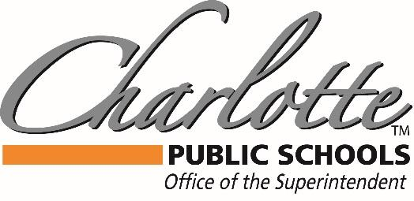

Dr. Mandy Stewart
378 State Street, Charlotte, MI 48813 PH: (517) 541-5100 FAX: (517) 541-5105
3/19/2020

CPS Families,
While this situation is fluid and we get new information all of the time, I thought I would check in with an update. Rumors are flying, and I wanted let our community know that as soon as we get guidance, we will communicate to you and post it on our website. As of this time, there has not been a change to the length of our school closure. We are slated to return 4/6, and if there is an extension we will let you know. Our School closures will always follow the directive of the state and our health department. So please stay tuned for updates by Skylert, Email and our website, charlotteorioles.com
Our Food programs have been successful, as of yesterday CPS served over 1600 meals to our local families. We will be asking for more donations for the food pantry as well, as the need has increased. A huge thank you to all of the workers and drivers that are keeping us going, as well as our essential staff that are busily communicating, cleaning, and keeping our district running.
We do not have guidance at this time about if days will need to be made up. MDE has asked for that guidance and it has not been answered at this time. MHSAA has stopped all games and practices during the closure, but there is still hope that sports can be continued upon our return, pending more information.
This is new territory for all of us, and trying to keep calm for our children while having to make and remake plans is very difficult. Be sure to prioritize your families, and spend some time enjoying your time together. Since many of you are balancing work, child care, and your potential new role as a homeschool teacher, you may need to take a break! We will all get done what we can, and any academic work is better than none. The Michigan teacher of the year, Cara Lougheed posted on twitter:
Cara@WonderTeach
“Just so everyone is clear: my children are not the least bit impressed at being homeschooled by the Michigan Teacher of the Year.”
We are all in this together, and from what I have seen from the Charlotte community, we will continue to support each other through this challenging time!
Stay safe, Wash your hands, and Go Orioles!
Dr. Stewart

