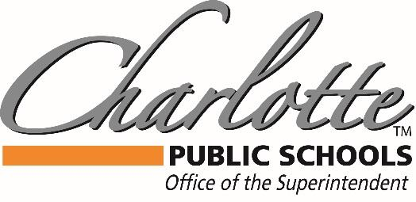

Dr. Mandy Stewart
378 State Street, Charlotte, MI 48813 PH: (517) 541-5100 FAX: (517) 541-5105
3/23/2020

Charlotte Public School Families,

Per the latest executive order from Governor Whitmer, we are in a Stay Home, Stay Safe through 4/13, with a tentative return date of 4/14. As things are rapidly changing, please utilize our website at https://www.charlotteorioles.com/our-district/covid-19-resources/ to stay updated on supports and information regarding Charlotte Public Schools. This Stay Home, Stay Safe does mean that all offices and child care will be closed as of 3/24-4/12.

As we move forward, please know that our food programs are allowable during a Stay Home, Stay Safe. This is considered essential, and you can pick up the food offerings at our multiple locations, until we are told otherwise. Our food schedule remains unchanged at this time. Also, when we get donations, especially perishables, we can sometimes offer more Bird Feeder options for donation boxes. While we will try to keep to our typical days of the week, if we have more opportunities, we will communicate for availability. Please stay tuned to our communication sources: Skylert, Emails, Social Media, and our website for updates.

The safety of our families is our priority, and staying home will help to “flatten the curve” of contagion. We do have many more questions than answers regarding the end of the school year, whether days will be forgiven, end of the year events, etc. As soon as we have that information, we will get it to you as soon as possible. Currently, we know that all events in the district are now cancelled through the Stay Home, Stay Safe current end date of 4/13, which includes Band Bounce. We know that there are many upcoming end of the year events in our community like Concerts, Spring Sports, and senior events that are causing much concern in the community. We also want to hold as many events on their scheduled dates as possible, but we can only do so with the recommendation of our government and health department. We will keep you as informed as possible on our website, social media, and through Skylert, so please check frequently.

There have been some conflicting communications between the Michigan Department of Education and the State of Michigan, regarding online learning as instructional time. It is my hope that we get more concrete direction, so that we can know how to support students. Currently, the advice is that we can provide enrichment and/or resources, but unless all students have access to a device and/or internet, we cannot fully transition to virtual learning. Our area has many gaps in internet service, and while we are working on solutions, we do not have the capability to ensure that all students have access.

However, as concerned educators and parents, we want to give every opportunity to support our students learning. We will continue to have our buildings communicate lessons/resources weekly, we will post learning ideas on our social media outlets, and continue to connect parents to resources through our website. While we cannot emulate what typically happens in our classrooms, with experienced educators, and student interaction, we can keep our students thinking academically and learning what they can at home.

This is a stressful time, and it is important to take the steps to stay well, physically and mentally. The executive order allows for families to get outside and exercise, while keeping social distancing standards, and frequent hand washing. Taking breaks to enjoy family and getting some sunshine can defiantly improve everyone’s emotional well-being!

Stay Safe and Go Orioles!

Dr. Mandy Stewart

Superintendent- Charlotte Public Schools

