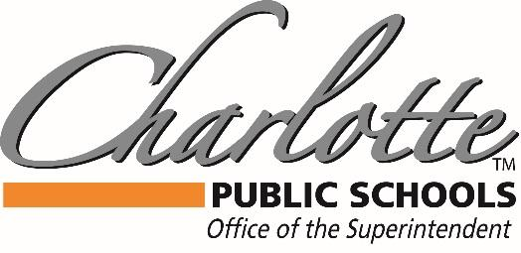

Dr. Mandy Stewart

378 State Street, Charlotte, MI 48813 PH: (517) 541-5100 FAX: (517) 541-5105

3/24/2020

CHS Senior Class of 2020,

This is an especially challenging time for you, as there are milestone events that we currently do not have direction on a timeline.  Please know that we want to have these events as much as you do, they are the reason we all went into education!  We are in talks right now about plans, back up plans, and back up to the back up plans. As we find out more, we will be communicating to you, to try and give every opportunity to recognize your stellar achievements. I have every faith that the state will support all seniors on their path to graduation, regardless of our current shut down, and we will continue to advocate for that support.

This class, as my first graduating class in Charlotte, is very special to me. My hope is that the end of your education at Charlotte Public Schools is everything you ever wanted, and we will look to postpone as opposed to cancelling events when possible, with the advisement of our health department.  While we are keeping your health and safety as a priority, we also fully acknowledge that this time is very special for you as seniors, and this uncertainty is very frustrating for you in particular. You are an amazing class, under very trying times, and we need to applaud how strong you have been as we navigate this situation. Thank you for all that you do, Class of 2020!

Stay Safe and Go Orioles!

Dr. Mandy Stewart

Superintendent- Charlotte Public Schools