Dear Charlotte Student-Athletes and Families,
We are obviously experiencing unprecedented events in the world these days, and I know that everyone is stressed and full of questions. While I cannot do much to relieve your stress and anxiety, and I don’t have all the answers you are looking for, I would like to send this message of hope and optimism to all members of the Charlotte Oriole family.
We do not know when school will resume, nor do we know what is going to happen with the sports seasons. What we do know is that the MHSAA is monitoring the COVID-19 situation and taking guidance from Governor Whitmer and other leaders, including medical professionals. I have heard a number of rumors regarding the spring sports season, and I want to assure all of you that NO decisions have been made regarding the cancellation or resumption of the seasons, despite what you may have heard.
At this time the MHSAA is in a holding pattern as they wait to see what the Governor decides to do about the remaining months of the school year. No decisions will be made to cancel or resume the sports seasons until that time. What I DO know is that the number one priority of the MHSAA and school leaders is the health and safety of our student-athletes, coaches, officials, trainers, families and spectators. Their number two priority is doing whatever they can safely do to allow our young people to be able to compete in their spring sports.
Please know that you are valued and thought of constantly as discussions take place regarding the resumption of the seasons. I have been in touch with representatives of the MHSAA and offered my assistance in any way that I can help. So far there isn’t much that any of us can do because of the tremendous amount of uncertainty regarding the spread of the virus. Like all of you, I am in “wait-and-see” mode.
I promise to keep you informed of all developments as I learn of them. Keep a positive attitude, athletes, and don’t give up hope. This message from the MHSAA says it pretty well:
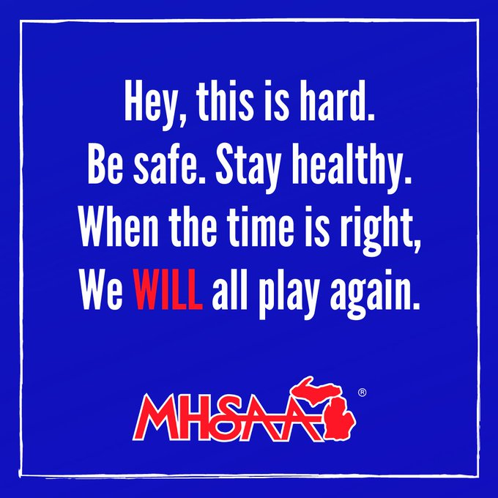

Stay safe and take care of your loved ones,
R. J. Guizzetti
Director of Athletics & Youth Recreation

