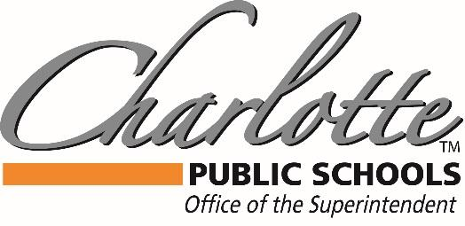

Dr. Mandy Stewart
378 State Street, Charlotte, MI 48813 PH: (517) 541-5100 FAX: (517) 541-5105

April 1, 2020

Due to Governor Whitmer's Stay Home, Stay Safe executive order in response to the COVID-19 pandemic, our Charlotte Public School Board of Education meetings will be conducted virtually. Our Special Board of Education Meeting on Thursday, April 2, 2020, at 6:00 p.m. will be streamed via YouTube to the public by clicking on the link below:
https://youtu.be/YU4xi_MdAkM

For anyone that is interested in public comment during Audience to Visitors, please complete the Google form below:
https://forms.gle/uTdVDAJnEgp3r9tr8

After completing this Google form, we will send to you via the email address you provided on the form, a phone number for you to call into the meeting. Please keep in mind that participation must be compliant with our public comment expectations:

- State your name and address prior to addressing the Board.
- Keep your comments limited to 2-3 minutes.
- Limit subject matter to issues only - please do not make any personal "attacks" directed at individuals.
Thank you for your interest in attending the CPS virtual Board of Education meeting!

Stay Safe, Stay Home and Go Orioles!

Dr. Mandy Stewart
Superintendent- Charlotte Public Schools

